Supplementary material
Commuter exposure to black carbon, carbon monoxide, and noise in the mass transport khlong boats of Bangkok, Thailand

Erik Velasco∗
Center for Environmental Sensing and Modeling, Singapore-MIT Alliance for Research and Technology, Singapore

Kelvin J.J. Ho, Alan D. Ziegler
Department of Geography, National University of Singapore, Singapore

The following tables and figures provide additional information about the instrumentation, measurements and results.

Instrumentation

Table S1. Description of instruments used in the study
Parameter | Instrument | Accuracy | Lower threshold | Model | Manufacturer
Black carbon (BC) | Micro - aethalometer | ±0.1 µg m⁻³ | 0.001µg m⁻³ | AE51 | AethLabs
CO | CO Measurer | 50 ppb | 1 ppb | T15n | Langan Products Inc.
Noise | Integrating Sound Level Meter | ±1.5% | 0.1 dB | TES-1353 | TES Electrical Electronic Corp.
Temp. and RH | HOBO Pro v2 logger | 0.2°C,  ±2.5% RH | 0.02°C at 25°C,  0.03% RH | U23-001 | Onset Computer Corp.
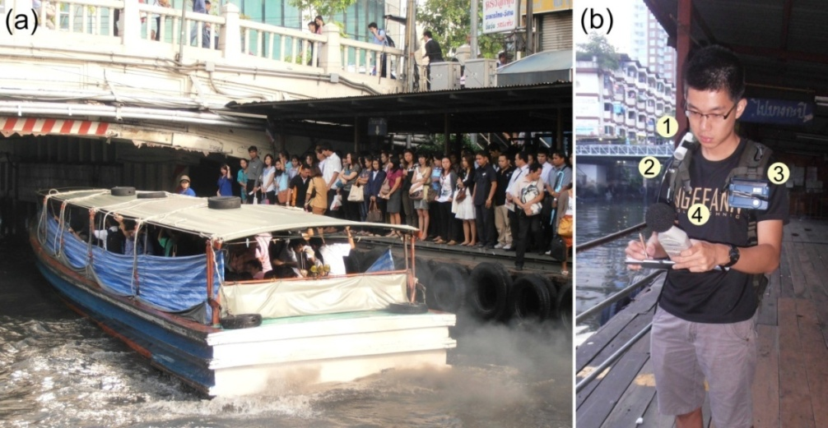

Figure S1. (a) Typical khlong boat approaching to Pratunam pier during the morning rush hour. (b) All instruments were carried at breast height, close to the breathing zone: (1) Temp./RH sensor, (2) micro-aethalometer inlet for black carbon, (3) carbon monoxide sensor, and (4) sound level meter.

Khlong Saen Saeb boats

The route selected for this study was the one running along the Saen Saeb canal, an artery passing through the heart of Bangkok. The Khlong Saen Saeb boats cover a route of 18 km in both directions by two lines. Both lines start at the commercial district of Pratunam, an interchange station for the two lines operating this canal. The eastern line runs to the outskirts of Bang Kapi (terminating at Wat Sriboonreuny) and the western line to the Ramkhamhaeng district (terminating at the Golden Mount). The boats operate from 5:30 to 20:30, departing approximately every 3 to 6 minutes. At night, they operate on demand. Fares range from 10 to 30 baht (0.33 to 1.00 US$) depending on the distance travelled. Additional information is available for this boat service in the Thai Mass Transport Systems Blog (http://thaitransit.blogspot.sg/).

Results

Table S2. Means (± one standard deviation) readings measured at the Pratunam pier and inside the boats along the Saen Saeb canal. Medians are presented in parentheses
Date | Sampling period (h) | BC  (µg m⁻³) | CO (ppm) | L_{eq}  (dBA) | Temp. (°C) | RH (%)
Measurements at Pratunam pier
May 16, 2012 | 11:40-13:00 | 29.7±64.6 (14.1) | 1.3±1.9 (0.8) | 73.3 | 33.0±1.5 (34.0) | 66.5±3.3 (66.0)
May 17, 2012 | 6:09-7:00 | 33.5±51.6 (17.1) | 1.2±1.1 (0.9) | 69.6 | 28.8±0.6 (28.8) | 85.0±1.2 (85.2)
 | 7:00-9:00 | 81.9±186.5 (37.4) | 3.2±3.4 (2.1) | 75.4 | 30.4±1.1 (30.1) | 79.8±3.5 (80.7)
 | 9:00-9:37 | 77.9±138.3 (43.9) | 3.7±3.0 (2.8) | 75.4 | 34.7±0.6 (34.8) | 65.9±2.9 (65.9)
 | 16:33-18:00 | 181.4±283.0 (111.2) | 7.1±6.6 (5.2) | 77.8 | 29.7±0.2 (29.8) | 83.3±1.4 (83.5)
 | 18:00-19:57 | --- | 5.2±5.8 (3.5) | 77.8 | 29.6±0.1 (29.6) | 84.9±1.1 (84.8)
May 18, 2012 | 6:08-7:00 | 23.8±32.5 (15.3) | 0.9±0.4 (0.9) | 69.7 | 27.5±0.2 (27.4) | 85.5±1.0 (85.7)
 | 7:00-9:00 | 136.2±138.9 (94.1) | 2.7±2.1 (2.1) | 76.2 | 29.8±1.0 (29.9) | 82.1±2.7 (81.8)
 | 9:00-10:12 | 154.4±207.6 (84.1) | 3.7±4.7 (1.8) | 75.6 | 31.8±0.3 (31.9) | 74.0±1.6 (73.5)
June 26, 2012 | 7:36-9:00 | 74.3±69.1 (56.4) | 3.6±2.9 (2.7) | --- | 31.4±1.2 (31.1) | 71.4±5.4 (72.0)
 | 9:00-11:05 | 58.4±46.5  (48.4) | 3.4±3.1 (2.5) | --- | 32.6±1.7 (32.2) | 67.2±4.3 (68.5)
June 27, 2012 | 7:00-9:00 | 95.8±92.1  (71.7) | 2.8±3.2 (1.9) | --- | 30.8±1.5 (30.4) | 73.3±5.6 (76.0)
 | 9:00-11:06 | 87.6±79.5  (68.9) | 3.5±3.3 (2.2) | --- | 32.6±1.3 (32.3) | 67.1±4.5 (68.4)
June 28, 2012 | 6:52-7:00 | 5.7±6.6  (3.8) | 0.3±0.3 (0.2) | --- | 29.5±0.1 (29.5) | 74.1±1.3 (74.1)
 | 7:00-9:00 | 105.2±169.5 (52.2) | 2.5±3.0 (1.6) | --- | 33.4±3.7 (31.7) | 64.0± 9.9  (69.0)
 | 9:00-11:26 | 71.6±117.6 (40.2) | 2.4±2.7 (1.7) | --- | 36.1±2.1 (36.4) | 52.7±5.9 (51.4)
Measurements inside the boats*
May 16, 2012 | 13:03-13:13  [P to WS] | 23.5±44.9  (12.3) | 0.5±0.8 (0.3) | 93.5 | 33.0±0.3 (33.0) | 66.5±1.1 (66.5)
May 16, 2012 | 13:18-13:28 [WS to P] | 14.8±35.2  (9.0) | 0.3±0.2 (0.3) | 93.8 | 32.6±0.1 (32.6) | 66.7±0.8 (66.6)
May 17, 2012 | 15:05-15:44  [P to WS] | 32.1±46.0  (18.0) | 2.1±1.0 (1.8) | 85.7 | 28.9±0.4 (29.1) | 86.0±0.7 (86.0)
May 17, 2012 | 15:51-16:26 [WS to P] | 72.8±162.3  (21.2) | 3.3±4.1 (1.8) | 97.7 | 28.3±0.2 (28.3) | 88.3±1.7 (88.9)
May 18, 2012 | 10:15-10:54  [P to WS] | 36.2±57.9  (20.9) | 0.4±0.6 (0.3) | 82.6 | 32.0±0.1 (32.0) | 71.7±0.4 (71.8)
May 18, 2012 | 11:10-11:49 [WS to P] | 411.2±916.3  (44.8) | 8.3±14.7 (2.1) | 89.6 | 32.9±0.1 (33.0) | 67.1±1.3 (67.0)
*Information in brackets in the sampling period column indicates the transect direction of travel when measurements were taken inside the boats: Pratunam to Wat Sriboonreuny or Wat Sriboonreuny to Pratunam (See Figure S2).
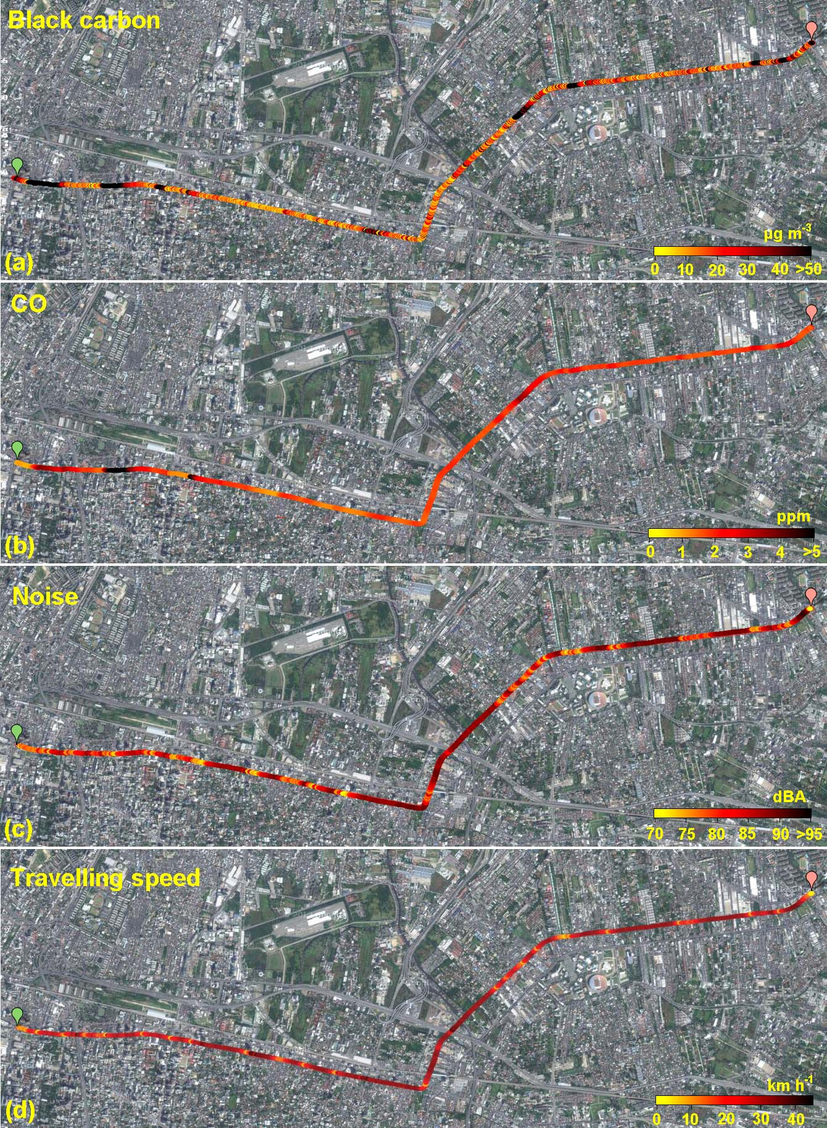
Figure S2. Black carbon, carbon monoxide, and noise levels measured during a trip from Pratunam (green spot) to Wat Sriboonreung (pink spot) along the Saen Saeb canal in a khlong boat. Measurements were conducted on 17-May-2012 from 15:51 to 16:26. Background map taken from Google-Maps©.

∗ Correspending author: evelasco@smart.mit.edu; evelasco@mce2.org

